DS-A4 | Model Comparison and Calibration Lab
Git-Hub access: https://github.com/alldeolove10-SJ/2026A8000531008_DEONISIO-YOHANES-WILFRIDUS-HORNAY_DS_A4_Model-Comparison-and-Calibration
Dataset: The local frozen CSV contains 569 observations, 30 numeric predictors, and a binary diagnosis label. The positive class is defined as malignant. The data are used here as an educational benchmark only, not for clinical decision-making. https://scikit-learn.org/stable/modules/generated/sklearn.datasets.load_breast_cancer.html
Protocol: Fixed stratified 80/20 train–test split (random_state=42); five-fold stratified cross-validation on the training portion; preprocessing is placed inside each pipeline. Local CSV SHA-256: af399a019264f7999e6b395ee90576e46564867aa4c8a40797c96be87dc1be55.

Main comparison

Model | ROC AUC | PR AP | Brier ↓ | ECE ↓ | Recall @ 0.5
Prior baseline | 0.500 | 0.368 | 0.233 | 0.005 | 0.000
Logistic regression | 0.996 | 0.994 | 0.021 | 0.030 | 0.929
Random forest | 0.995 | 0.993 | 0.031 | 0.052 | 0.929
Hist Gradient Boosting | 0.991 | 0.991 | 0.025 | 0.029 | 0.929

Interpretation boundary
In this run, the prior-only classifier is a deliberately weak reference point, while the trained classifiers separate the two labels much more effectively on this fixed split. Discrimination scores (ROC AUC and average precision) do not by themselves establish good probability calibration or a suitable operational threshold. Brier score and ECE complement ranking metrics, but ECE depends on the chosen binning method.
Important: the threshold cost grid uses hypothetical cost ratios and review-capacity levels to illustrate sensitivity. It is not a final policy recommendation. You must justify the real decision costs, human capacity, threshold rule, and claim limits before submission.

Discrimination: ROC and precision–recall
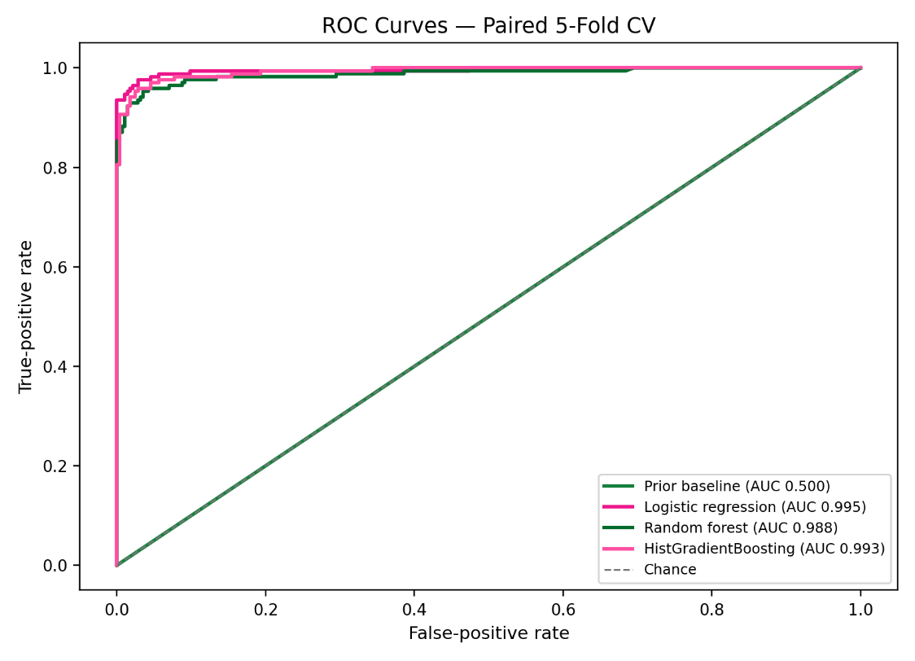
Figure 1. ROC curves from paired five-fold cross-validation on the training portion. The curves summarize ranking across thresholds; they do not choose a threshold.
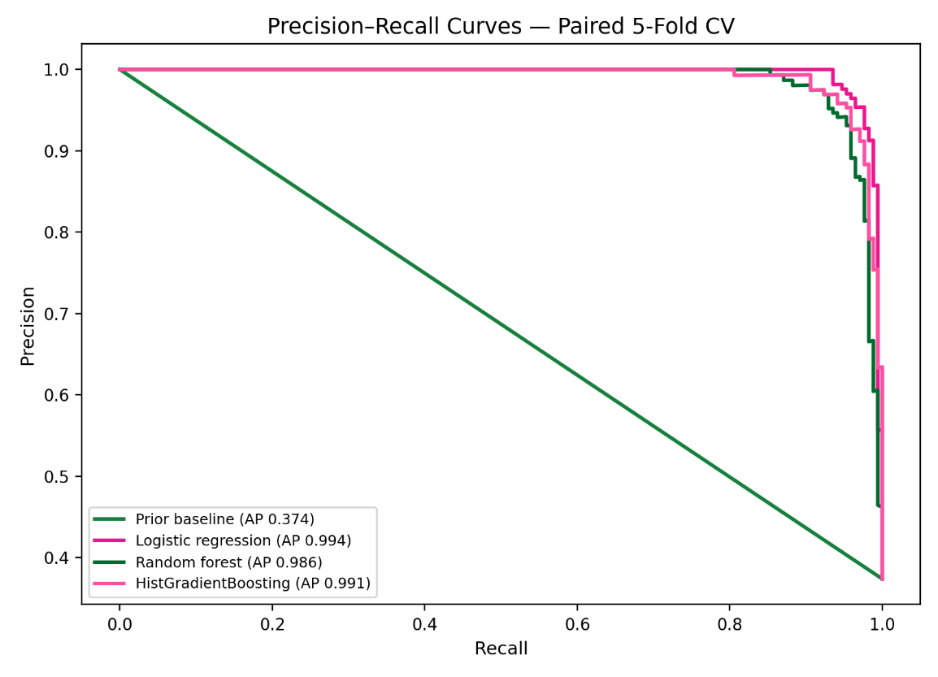
Figure 2. Precision–recall curves. Average precision is useful when the positive class is not equally common, but the preferred metric should be justified against the intended decision.

Probability quality and metric comparison
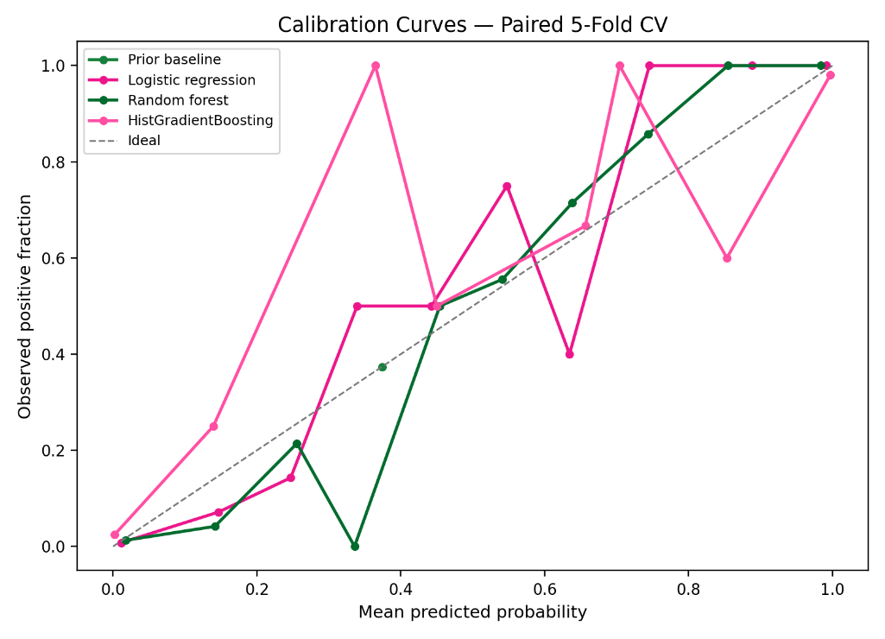
Figure 3. Calibration curves compare predicted probabilities with observed positive fractions. A curve closer to the diagonal indicates better calibration, subject to sampling variability and binning.
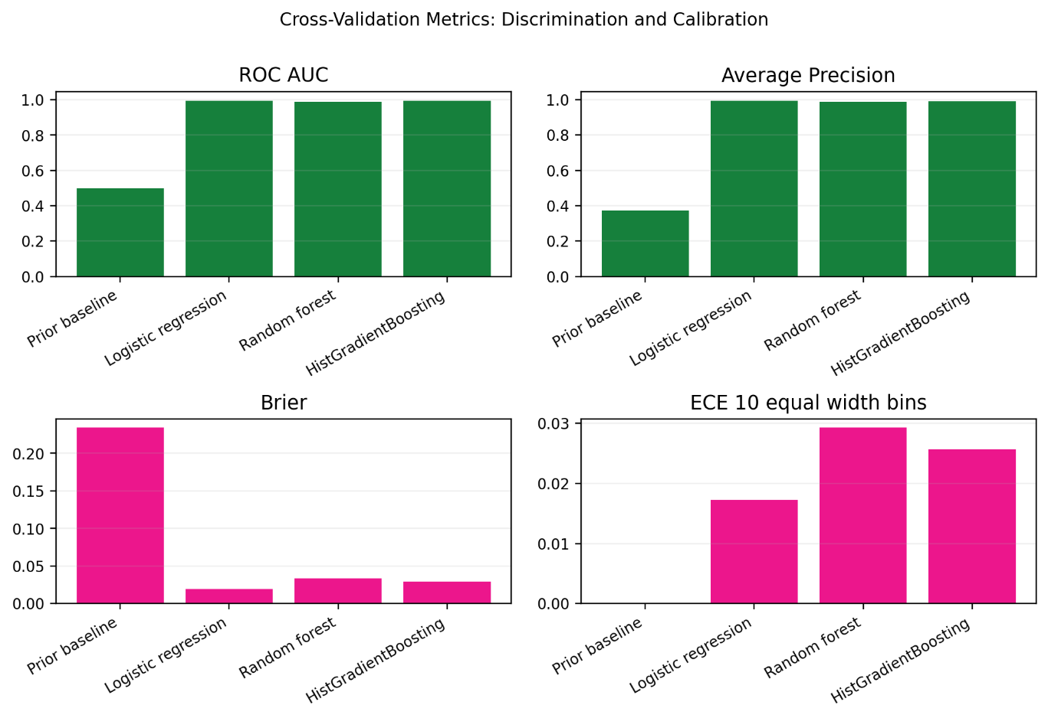
Figure 4. Cross-validation comparison of ROC AUC, average precision, Brier score, and ten-bin equal-width ECE. Lower Brier and ECE are better; the ECE definition is recorded in the code.

Threshold sensitivity and critical-slice check
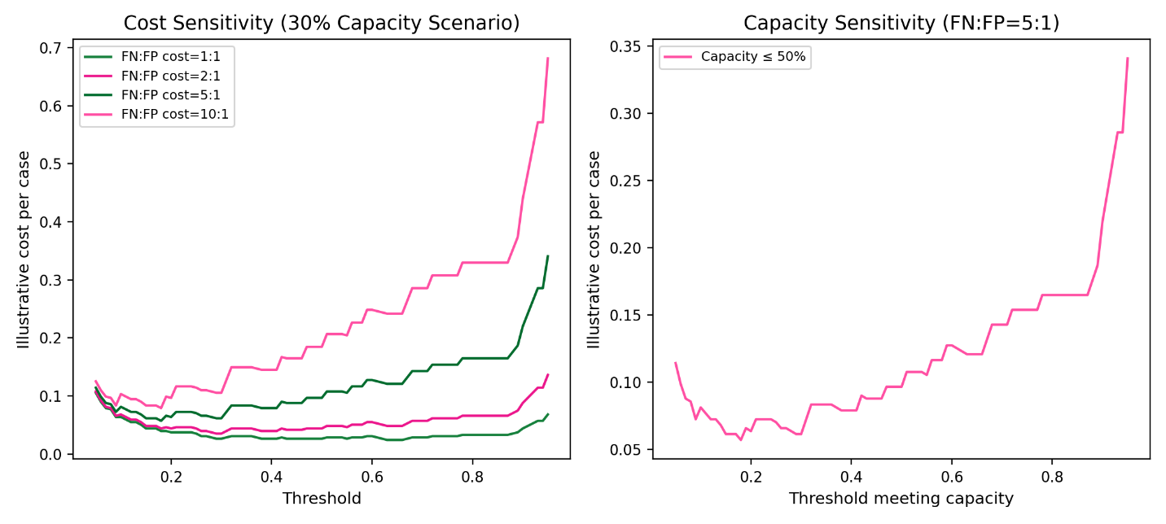
Figure 5. Illustrative threshold-cost sensitivity for logistic regression. The cost ratios and review-capacity values are scenarios, not verified real-world utilities. The chosen threshold must be tied to justified costs and capacity.
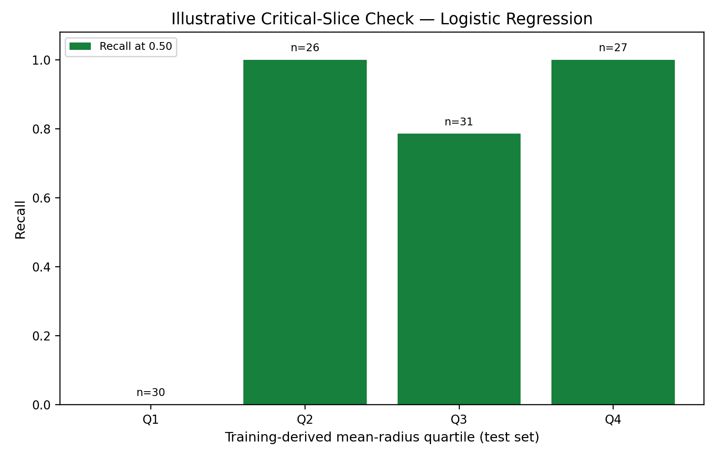
Figure 6. Exploratory check across training-derived quartiles of mean radius. This is a feature slice, not a fairness audit. Some groups have small sample sizes or only one observed class, so group-level metrics can be unstable or undefined.

Paired uncertainty and limitations
The paired bootstrap estimate for out-of-fold average precision (logistic regression minus prior baseline) is 0.621, with a case-resampling 95% percentile interval of [0.577, 0.665]. This interval conditions on the available out-of-fold predictions and does not capture all model-training or dataset-shift uncertainty.
This dataset is not a clinical model and these results do not support medical use.

